1. Refer to the exhibit. Which IP address and subnet mask can be configured on host H1 if it is to communicate with the network?
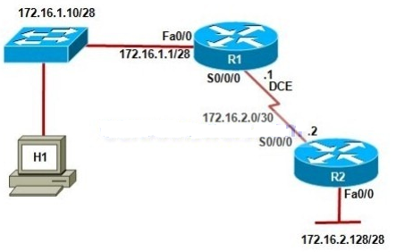
- 172.16.1.0 255.255.255.248
- 172.16.1.14 255.255.255.240
- 172.16.1.17 255.255.255.240
- 172.16.2.1 255.255.240.0

2. What statements describe how hosts on VLANs communicate?
- Hosts on different VLANs are connected using a trunk lines
- Hosts on different VLANs communicate through routers.
- Hosts on different VLANs should be in the same IP network.
- Hosts on different VLANs examine VLAN ID in the frame tagging

3.Which statement correctly describes a feature of RIP?
- RIP is a link-state routing protocol.
- RIP uses only one metric—hop count— for path selection.
- Advertised routes with hop counts greater than 10 are unreachable.
- Messages are broadcast every 10 seconds.

4.Refer to the exhibit. R1 is performing NAT for the 10.1.1.0/24 network, and R2 is performing NAT for the 192.168.1.2/24 network. What would be valid destination IP address for HostA to put in its IP header when communicating with the web server?
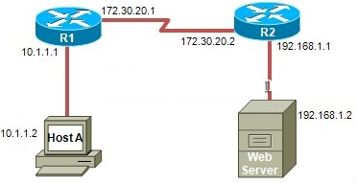
- 10.1.1.1
- 172.30.20.2
- 192.168.1.2
- 255.255.255.255

5.Which service is used when the nslookup command is issued on a computer?
- FTP
- DNS
- DHCP
- Telnet

