I-NAME Resource Management

1. Introduction

Traditional network management tasks are solved outside the network, based on protocol interaction between central entities and managed devices. In-Network Management (INM) solution proposed a management concept contrasting the traditional centralized network management paradigm. INM tasks are distributed into the network, making the network more intelligent by embedding management intelligence in the network. In this way, management tasks are transferred from the management entities outside the network in an autonomic and self-organizing management plane located inside the managed system.

2. I-NAME

It is up to the application to request for resources in the network, but it is up to the network to know its behavior. In other words, in order to enable an autonomic behavior of the network, the resource management functionalities must be placed into the network’s entities.
We propose I-NAME (In-Network Autonomic Management Environment), as autonomic reacting environment that generates a set of management messages for resource control and maintenance accordingly to the dynamically changing network's configuration.
The scope of I-NAME is to add predictions in the network, by monitoring and collecting information in the network based on a set of management messages (profiles). I-NAME defines profiles as aggregate QoS parameter sets (throughput, delay, jitter, packet loss, etc.) and gives personalized access (from the user point of view) and optimized services (from the network/operator perspective). I-NAME implementation requires a set of messages exchanged between network entities. These messages (profiles) are described in [1].
Considering all the above assumptions, the role of I-NAME is to enable the network entities with capabilities that automatically detects dynamically changing network configuration and reacts accordingly to the service requests.

3. I-NAME: INM solution and relation with VN

Network autonomy is an integrated IMN principle. In the mean time, one of the INM tasks is the network resource management. This means that management does not involve any external manual operation, consequently a fully self-management plane including resource management.
I-NAME works in this self-organizing management plane as a resource management function, adapting user/application requests to the network capabilities.
As mention in [1], a self-management function (even I-NAME) could go beyond INM adaptation of user/application parameters according to the network availabilities; it could assist the deployment of services through virtual resources indicated in a VN (Virtual Network).
Considering that multiples VNs may share the same overlaying physical/substrate network, virtualization could involve only the best and optimal network topologies (substrate nodes and links/paths) selected in the INM process [2]. For example, working on network substrate with different weights/priorities for parameters requested in the user/application profiles, I-NAME could assist VNs mapping process; offering profiles that include parametric description of substrate nodes or substrate links/paths selected in the resource management process, I-NAME could indicate the optimal substrate nodes and the substrate link/path topologies that guarantee the best average end-to-end delay or throughput in the network. Defining a proper API of the Virtual Manager, I-NAME could give support for the virtualization framework.

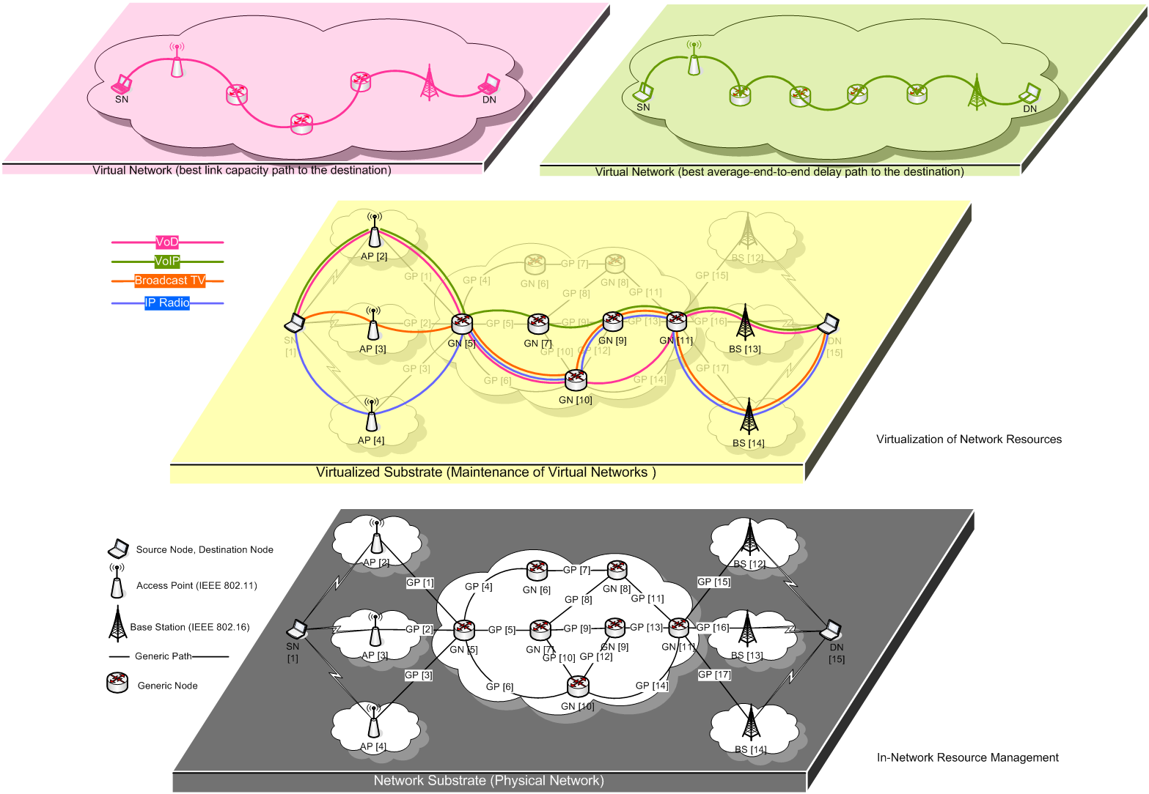

Figure 1. I-NAME: solution for INM and relation with VN

Acting on the network substrate, I-NAME works for INM resource management in a distributed manner. Depending on the application type (VoD, VoIP, Broadcast TV, IP Radio, etc.), there are different application requests expressed in terms of QoS parameter set. I-NAME define this QoS parameter set as QoS profile.
I-NAME QoS profile message flow selects the best path from the source node (SN) to the destination node (DN), based on the weight of application parameters (delay, throughput, jitter).
Depending on the application type and QoS parameter priorities, I-NAME resource management algorithm indicates the best paths in the network always adapted to the user requests in terms of the best average end-to-end delay path or best link capacity path to the destination.
Indicating only the substrate nodes and substrate links/paths based on user request, I-NAME set up on-demand VN topologies with different capacity parameters over the shared network substrate. Form the VN perspective, physical infrastructure parametric-base partitioning could be view as a part of virtualization process and the best average end-to-end delay path or best link capacity path to the destination could be viewed as separate virtual networks (VNs).

References:
[1] In-Network Management Concept, Public document number FP7-ICT-2007-1-216041-4WARD / D-4.2, February 2009, http://www.4ward-project.eu/index.php?id=64.
[2] Houidi, I.; Louati, W.; Zeghlache, D., A Distributed Virtual Network Mapping Algorithm, IEEE International Conference on Communications (ICC 2008), Beijing, China, 19-23 May 2008, pp. 5634 – 5640.

