Document Properties:
Document Number: | FP7-ICT-2007-1-216041-4WARD / <number>
Document Title: | Autonomic Networks
Document responsible:
Author(s)/editor(s): | Emanuel Puschita, Tudor Palade, Virgil Dobrota
Target Dissemination Level: | PU
Status of the Document: | Draft
Version | 0.1
Production Properties:
Reviewed by:
Revision History:
Revision | Date | Issued by | Description

This document has been produced in the context of the 4WARD Project. The research leading to these results has received funding from the European Community's Seventh Framework Programme ([FP7/2007-2013] [FP7/2007-2011]) under grant agreement n° 216041
All information in this document is provided "as is" and no guarantee or warranty is given that the information is fit for any particular purpose. The user thereof uses the information at its sole risk and liability.
For the avoidance of all doubts, the European Commission has no liability in respect of this document, which is merely representing the authors view.

Abstract:
<Optional>

Keywords:
I-NAME, resource management, resource reservation, QoS parameters

Terminology and assumed definitions
INM (In-Network Management): In context of autonomic networks the role of INM is (1) to observe, (2) to analyze and (3) to offer in-network management functionalities in order to be acted in-the-network. The INM must be designed for (1) services management, including (a1) resource control, (b1) resource maintenance, etc., and (2) network management, including (a2) traffic balancing, (b2) routing assisting, (b3) network selection, etc.
In a live network, a distinction can be made between two sets of functions: (1) RT (Real Time), related to ongoing sessions (classical control plane tasks; real time), and nRT (non Real Time) (2) related to network elements themselves, independently of individual sessions (classical network management, rather minutes/hours cycles).
FC (Functional Component) integrates management capabilities in order to participate in the execution of a management function or algorithm [1].
According to the degree of embedding [2], there are three INM categories of functions: inherent management functions, integrated management functions, and separated management functions. All these categories will define the MoF (Matrix of Functionalities): inherent, attached or external to a FC.
InNetMgmt Application: a resident process implementing a set of standard messages used for managing the network elements and resources.
Hence, each management function (included in the MoF) must be defined accordingly to the network node’s degree of embedding [2], located in the space of the high level node architecture [3], and correlated with the network and services space.
I-NAME Protocol (In-Network Autonomic Management Environment Protocol): autonomic reacting environment that generates a set of management messages for resource control and maintenance accordingly to the dynamically changing network’s configuration.
Entity: a network element that could be viewed as a network node. There are different types of entities accordingly to the capabilities of the entities. (e.g. access entity, core entity, distribution entity).
Domain: includes all types of entities sharing the same categories of functionality. INM functionalities will delimit to a domain. A domain will integrate entities sharing the same functionalities. The borders of the domain will be defined as the limit of that functionality. (e.g. access domain, core domain, distribution domain).

Introduction
Today’s telecommunications world is increasingly characterized by a multiplicity of access technologies, fixed and mobile, as well as different flavours of both of them. These technologies have generally evolved from legacy independent architectures to heterogeneous access, with little real attempt to achieve inter-working.
Users expect to be able to connect to a broadband network, irrespective of time, terminal, location, and operator in order to access resources both in client-to-client sessions as well as centralized broadcast service delivery, and they also prefer to experience different access networks as one transparent single network.
Users have potential access to mobile networks, satellite networks, DSL fixed networks, digital terrestrial broadcast networks and more. Also, many mobile users’ terminals today implement 3G, WiFi, WiMAX and Bluetooth interfaces, and the strategies for connecting to the IP networks behind these access networks generally result only in very simple selection of one of the available networks, often requiring user interaction and configuration tasks.
It is obvious that a traditional management is not appropriate, because the idea of an exclusive centralized system that has control over users and resources does not fit the actual need of a user located inside the heterogeneous wireless/wireline system any more, especially when some inter-access system tasks are required. These are almost undefined today. For example, 3GPP TS23.234 defines Integrated WLAN (I-WLAN)
Current trends could involve: globalness, in-network implementation, activeness, cost effectiveness, scalability.
- Globalness. With the expected increase in number and scale of future networks, the mechanism intends to manage the inter-domain resources of an operator that integrates multiple users (wireless/wireline terrestrial and spatial wide area networks, wireless/wireline metropolitan, local, and personal area).
- In-Network implementation. User terminals will implement multiple access technologies, but the subscriber still has to select one network. Today’s management access mechanisms are generally limited to selecting a single path, considering alternative or even parallel paths to be used in case of transmission failures. Starting an application requires users to manually select, probably switch between different access networks and maybe also manually specify which applications may use which networks at which time. This consideration leads to the idea of network-based mechanisms, functions that are integrated into the to-be-managed networks and use all necessary and available means of the traditional control and network management planes.
- Activeness. In mobile scenarios, conditions of the access networks change rapidly (inter-symbol interference, channel throughput, available radio resources, signal-to-noise ratio, etc.), making manual control useless. Moreover, the network can offer a significant increase in capacity and the user could reach higher throughput, more reliable connectivity or lower costs, if such control could be provided. Even if a subscriber has access to manual configuration and network selection, there is currently no advertised on alternative, heterogeneous network resources. This consideration requests for an active adaptable in-network control mechanism which reacts to changes.
- Cost effectiveness. The mechanism must adapt to user’s application requests and to network’s changes by some means of quality control. Additionally, users still need a way to control network usage due to cost considerations. This reasoning illustrates a need for per-user/application costs evaluation where user’s supported costs are taken into account. Cost effectiveness is also important for the future operator of the heterogeneous access network environment, i.e. how to improve today’s situation with multiple independent and expensive “silo” solutions. Secondly, the operator wants to extend and optimize the coverage, which may lead to lower spectrum costs.
- Scalability. The architectural active access environment enables users/applications to have simultaneous possibilities of connecting to several access networks at the same time, limited only by some near field radio issues. From the operator’s point of view it is important that the business can grow without major network restructuring and cost. This means that the replacement of access system elements and network elements can be done as business grows without generating a major impact on the management mechanism.

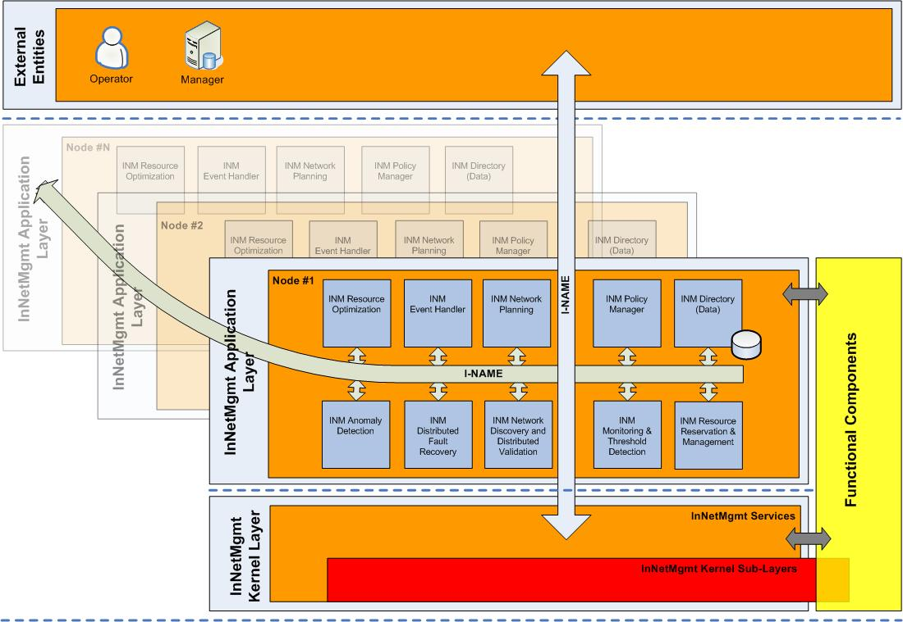
Figure 1. Functional Architecture Picture

I-NAME integration into the InNetMgmt High Level Architecture
Considering the above assumptions, the scope is to design an in-network management environment (I-NAME, In-Network Autonomic Management Environment) that enables the network entities automatically (1) detects the dynamically changing network’s configuration (resource management function), and (2) reacts accordingly to the service’s requests (resource reservation function)
Each integrated management function, defined inside the functional architectural picture [4], must be linked to one or more modules located inside INM Framework/INM Platform of an FC. In case of INM Resource Reservation and Management functions, designed for both RT and nRT network’s states, linked to the following modules (QoS Module, Routing Module, and Management Kernel. [5]
I-NAME implementation requires a set of messages exchanged between entities placed in INM Application space and INM Kernel space. These messages are called profiles (see Figure 2.).
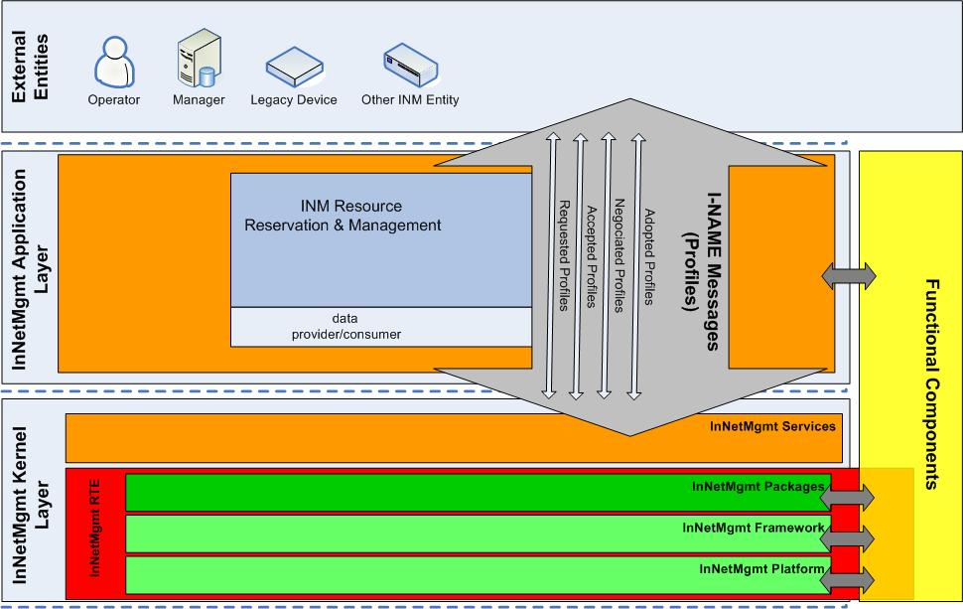
Figure 2. Dependencies inside InNetMgmt High Level Architecture picture for INM Resource Reservation and Management functions
I-NAME Protocol implementation requires a set of messages exchanged between entities placed in a given environment (i.e. Network Node).
Considering the above definitions and assumptions, the scope is to design an in-network management protocol (I-NAME, In-Network Autonomic Management Environment) that enables the network entities automatically (1) detects the dynamically changing network’s configuration, and (2) reacts accordingly to the service’s requests.
It is up to the application to request for resources in the network, but it is up to the network to know its behaviour. In other words, in order to enable a reactive behaviour of the network, the management functionalities must be placed into the network’s entities, in-network.
The scope of I-NAME is to add predictions in the network, to monitor and collect resources in the network based on a set of management messages are called profiles. I-NAME defines profiles as aggregate QoS parameter sets. The goal of I-NAME is to give personalized access (from the user point of view) and optimized services (from the network/ operator point of view). The role of I-NAME is to implement and generate this set of messages needed for collection, negotiation, modification and transfer of a QoS parameter set based on users interaction according to in-network’s availabilities. The QoS parameter set will include parameters like throughput, delay, jitter, packet loss, etc. All these costs will defines so called profiles. This parameter set is required for making optimal decisions regarding the parameter’s distribution across the network, in order to have the best resource control.
I-NAME protocol is based on the messages exchanged between entities, on the interaction and decision according to the information negotiated by using profiles.
I-NAME defines profiles, as the QoS parameter sets requested, supported, negotiated, and adopted in the I-NAME message flow between the in-network management architecture’s elements (i.e. Mgmt kernel, QoS module, Routing module, GP, etc.). Considering this, the profile will determine path’s cost.

I-NAME Description

Scenario Description
I-Name is design to operate in a scenario as presented in the Figure 3.

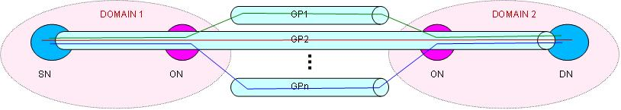

Figure 3. I-NAME Operating Scenario and Network Elements
For the given scenario, we have the following network elements:
SN – Source Node (Home Network)
ON – Operator Node (Home Network)
DN – Destination Node (Home Network)
GP – Generic Path (WiMAX, UMTS, Satellite, etc.)
HN – Home Network
Multiple paths between source and destination

I-NAME’s Protocol Profiles
I-NAME defines four types of profiles:
- Requested profile: includes application’s request for resources; it is generated by the SN. SN requests for a specific resource reservation profile for the given application.
- Accepted profile: express the destination’s availability for resources announced in the requested profile; it is generated by the DN. DN sends an message indicating the acceptance for requested parameters.
- Negotiated profile: express the destination’s possibilities for resources announced in the requested profile; it is generated by the DN. DN sends an message indicating the possibilities for requested parameters.
- Adopted profile: express the source’s availability for resources announced in the negotiated profile; it is generated by the SN. SN sends a message indicating adopted parameters.

Message flow description
I-NAME’s Protocol message flow is based on the interaction and decision according to the information included in the profiles. Depending on SN/DN availability, I-NAME message flow is designed for two or three phases.
These message flows suppose that the network could offer at least one GP between SN and the DN. The profiles should carry the network’s capabilities from node to node in the path to the destination, but only the SN and DN could choose between different profiles in order to have a common view of the application’s requirements.

Two-phase management message flow

GP1
GP2
GPn
DOMAIN 1
ON
DN
ON
SN
1
2
3
6
5
4
DOMAIN 2
Figure 4. Two-phase management message flow
Messages 1, 2, and 3 represent the requested profile. If in each node on the path form SN to the DN the profile identifies the costs for each GP, the DN will have the best path that offers support for application’s QoS parameter set.
If DN is able to run the application in terms of QoS parameters, it indicates the acceptance by sending messages 4, 5, and 6. Messages 4, 5, and 6 represent the accepted profile.
In case of two-phase management message flow, messages 4, 5, and 6 sould also be used to reserve the resources in network nodes, form DN to SN.

Three-phase management message flow
GP1
GP2
GPn
ON
DN
ON
SN
1
2
3
6
5
4
7
8
9
DOMAIN 1
DOMAIN 2
Figure 5. Three-phase management message flow
Messages 1, 2, and 3 represent the requested profile. If in each node on the path form SN to the DN the profile identifies the costs for each GP, the DN will have the best path that offers support for application’s QoS parameter set.
If DN is not able to run the application in terms of QoS parameters, it announced in the negotiated profile destination’s possibilities by sending messages 4, 5, and 6. Messages 4, 5, and 6 indicate the supported QoS parameters at the DN.
Based on the parameters indicated in the negotiated profile, the adopted profile will express the SN availability for resources announced in the negotiated profile. Messages 7,8, and 9 indicate the QoS parameters adopted for the current session.
In case of three-phase management message flow, messages 7, 8, and 9 should also be used to reserve the resources in network nodes, form SN to DN.

Resource Reservation Algorithm
The two-phase management message flow algorithm is illustrated in Figure 4. In this case the DN reserves the resources on the path to the SN.

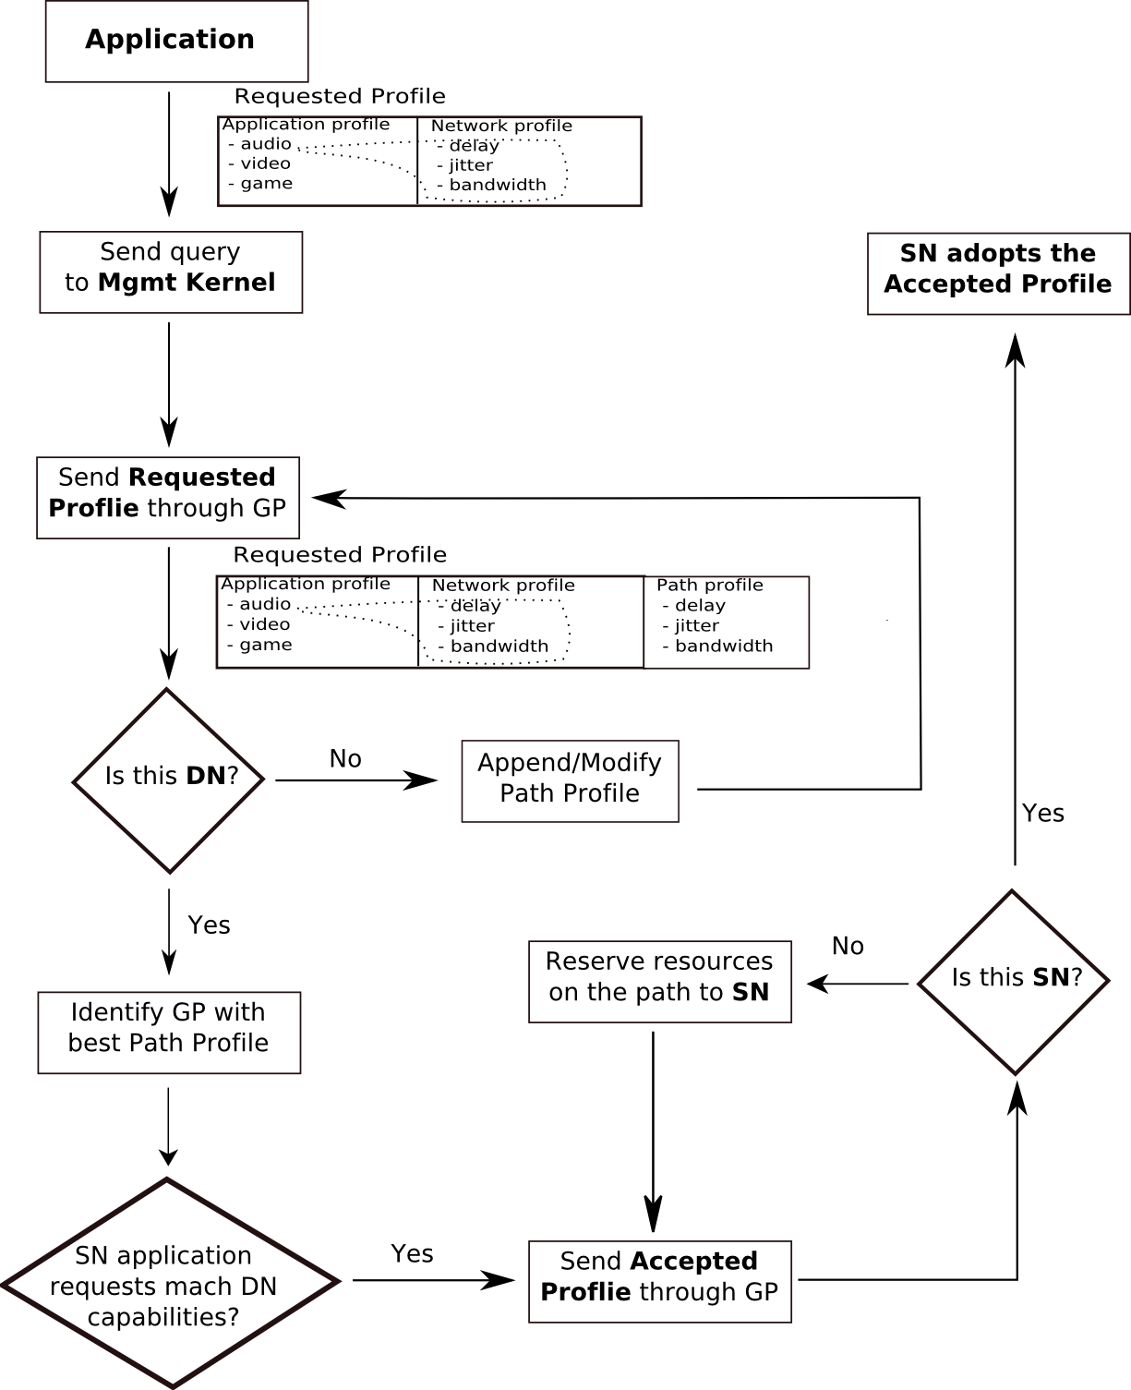
Figure 6. Two-phase management message flow algorithm

The three-phase management message flow algorithm is illustrated in Figure 5. In this case the SN reserves the resources on the path to the DN.
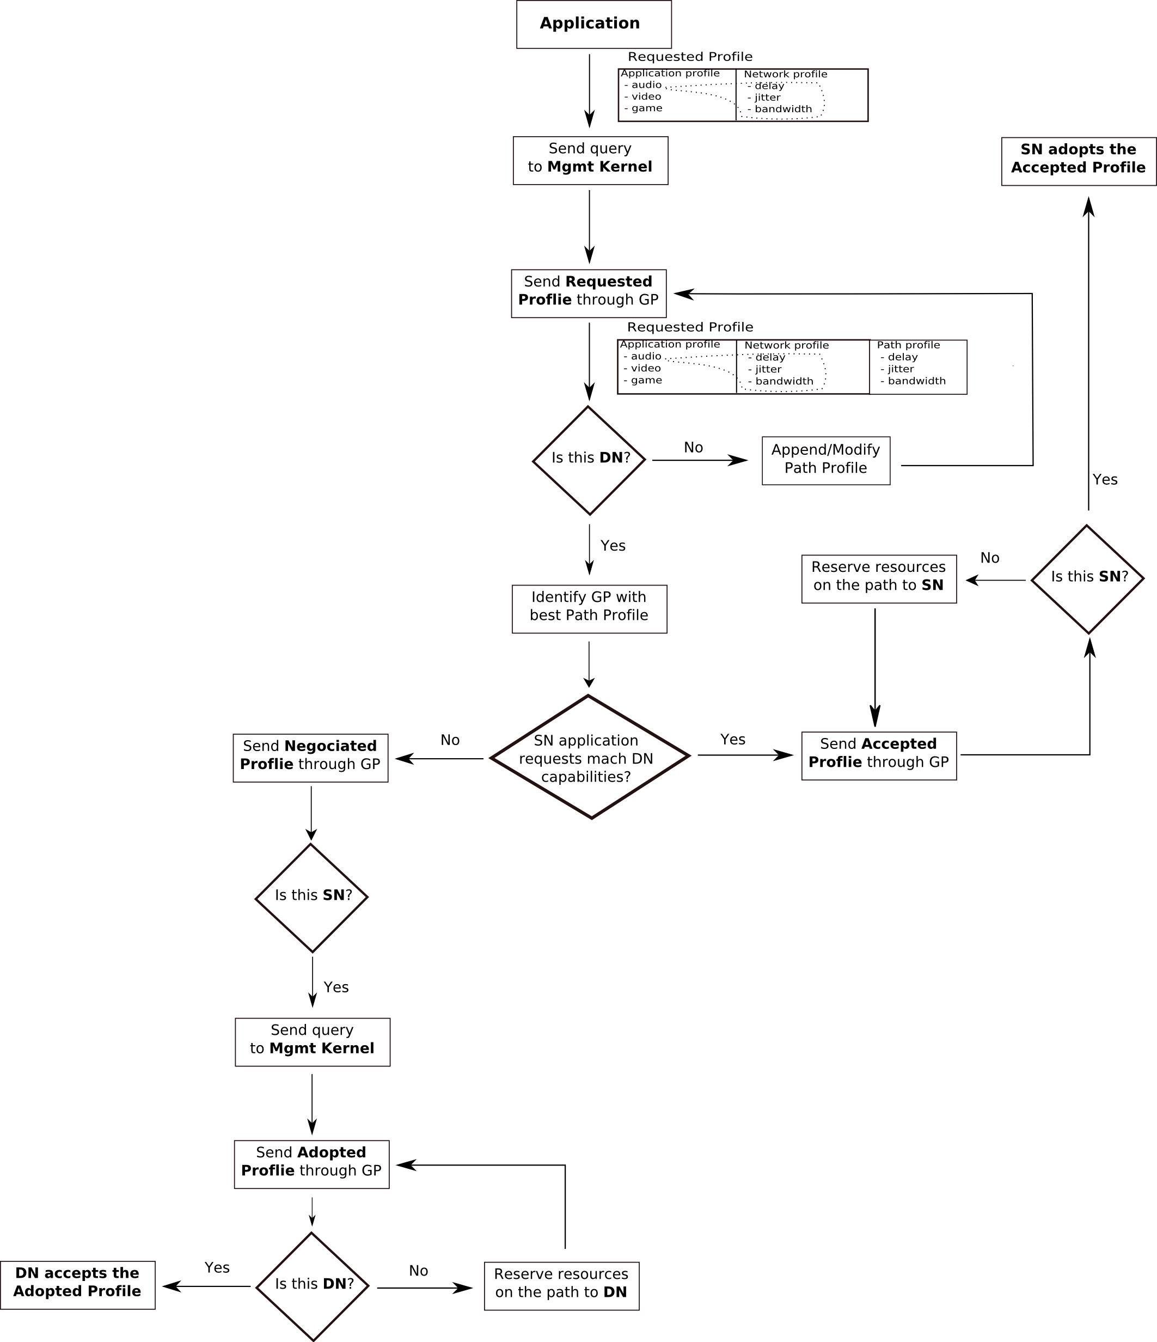

Figure 7. Three-phase management message flow algorithm

References:
[1] https://wiki.verkstad.net/bin/viewauth//FI/InNetMgmtArchitectureConcepts
[2]https://subversion.verkstad.net/4ward-documents/Workpackages/WP4-InNetMgmt/TechnicalMaterial/Task2_Architecture/4W_W4_Architecture_Degree_Embedding.ppt
[3]https://subversion.verkstad.net/4ward-documents/Workpackages/WP4-InNetMgmt/TechnicalMaterial/Task2_Architecture/4W_W4_Architecture_Degree_Embedding.ppt/4W_T42_InNetMgmt_High_Level_Architecture.ppt
[4] https://wiki.verkstad.net/FI/T44FunctionalArchitecture
[5]https://subversion.verkstad.net/4ward-documents/Workpackages/WP4-InNetMgmt/TechnicalMaterial/Task2_Architecture/4W_T42_Framework_Instantiations.ppt

Input of Title, Date,Version, Target disseminationlevel, Status via “File /Properties/Custom” in the Word menu
Format: FP7-ICT-2007-1-216041-4WARD /<Deliverable number> Example: FP7-ICT-2007-1-216041-4WARD / D-1.1
Dissemination level as defined in the EU Contract: PU = Public PP = Distribution limited to other programme participants RE = Distribution to a group specified by the consortium CO = Confidential, only allowed for members of the consortium

