I-NAME Simulation Tests Scenario Description

A specific network topology when using QualNet Developer is referred to as a scenario. A scenario allows the user to specify all the network components and conditions under which the network will operate.
In order to demonstrate I-NAME capabilities on managing in-network resources, we model multi-domain network architecture scenario. This includes channel propagation effects, antenna characteristics, operating channels selection, path loss, fading and shadowing models, wired and wireless subnets, network elements configuration, protocol stack selection including a variety of standard, and applications running on the network.
Managing network resources in a distributed manner, each network parameter has an important impact on network performances. Next paragraphs include all the above global parameter configuration settings and the particular parameter description.

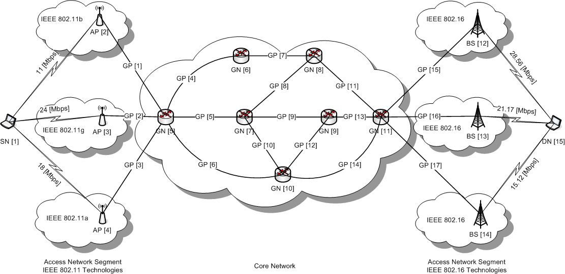

Figure 1. I-NAME simulation tests scenario

I-NAME simulation tests scenario integrates wireless and wireline technologies. The multi-domain scenario includes two wireless access segments (IEEE 802.11 and IEEE 802.16) connected through a wireline core network segment (Ethernet).
In the wireless subnets we integrate different radio models implementing local area network characteristics like IEEE 802.11 a/b/g, and metropolitan area network characteristics like IEEE 802.16. All this technologies operates on specific radios.
We use the following notation in Figure 1: SN – Source Node, DN – Destination Node, GP – General Path, GN – General Node, AP – Access Point, BS – Base Station. Each network component is identified by an [element ID] marked between square brackets.

- Global parameter configuration settings

This section describes the parameters for setting up radio channels, radio models, frequencies according to the radio technology used, antenna parameters, path loss, shadowing model, receiver sensitivity and propagation shadowing in the wireless scenario. The parameters for configuring channels and their properties are described in Table 1.

Radio Model | Frequency  [GHz] | Receiver Sensitivity [dBm] | Radio  Propagation Model | Propagation Shadowing Model | Propagation Shadowing Mean
802.11a | 5 | -111 | Two-Ray | Constant | 4.0
802.11b | 2.4 | -111 | Two-Ray | Constant | 4.0
802.11g | 2.4 | -111 | Two-Ray | Constant | 4.0
802.16 | 2.5 | -111 | Two-Ray | Constant | 4.0
802.16 | 2.5 | -111 | Two-Ray | Constant | 4.0
802.16 | 2.5 | -111 | Two-Ray | Constant | 4.0

Table 1. Radio channel properties

The physical wireless layer needs to be defined by specifying the radio model. Radio model integrates standard specification for each model selected and characterizes the transmitter/receiver behavior at an interface. For each specific radio model there is defined a supported reception model at the receiver.
Receiver sensitivity defined by the Two-Ray propagation model indicates the propagation limit, the threshold for delivering signals to nodes. The constant shadowing model uses a constant shadowing offset indicated by the propagation shadowing mean. The co-channel interference and co-location aspects are solved by using a channel mask associated to the channel description.
For wireless networks, on the physical layer we need also to define and configure antenna model and associated antenna losses. Antenna model represents the characteristics of radio antennas. The major characteristics of an antenna are the gains it provides during transmission and receiving, and the efficiency or loss due to various mechanical and electronic factors.
We used omni-directional antennas that provide the same antenna gain irrespective of the signal direction. Specific antenna gains are provided for each transmitting node in the next section. Antenna parameters description is presented in Table 2.

Antenna Characteristic | Value
Antenna Radiation Pattern | Omni-directional
Antenna Height | 1.5 m
Antenna Mismatch Losses | 0.3 dB
Efficiency | 0.8
Cable Losses | 0 dB
Antenna Connection Losses | 0.2 dB

Table 2. Antenna parameter description

- Specific parameter configuration settings

I-NAME in-network management performances are tested in complex network scenario context. We run a time-critical application form the source node to the destination node, through the core network.
The source node is located in the IEEE 802.11 network segment, while the destination node is located in the IEEE 802.16 access segment. Both source and destination node have the possibility to be attached to one of multiple existing access network technologies inside each given network segment. Next we give specific configuration settings for each segment of the multi-domain network environment.

IEEE 802.11 Access Network Segment
Access Network  Technology | Source Node  [node ID] | Access  Point  [node ID] | Channel Throughput  [Mbps] | Transmission  Radio Range  [m] | Beacon  Interval  [sec] | Transmission  Radio Range  [m]
802.11b | 1 | 2 | 11 | 150 | 200 | 150
802.11g | 1 | 3 | 24 | 50 | 200 | 50
802.11a | 1 | 4 | 18 | 150 | 200 | 150

Table 3. Source node [node ID] = 1 attached to IEEE 802.11 network segment through different access interfaces

Under the IEEE 802.11 network segment, we define three particular access radio technologies/models: IEEE 802.11a, IEEE 802.11b, and IEEE 802.11g.
IEEE 802.11a radio model operates in the 5 GHz frequency band, using Orthogonal Frequency Division Multiplexing (OFDM) and supports the following data rates (in Mbps): 6, 9, 12, 18, 24, 36, 48, and 54.
IEEE 802.11b radio model operates in the 2.4 GHz frequency band uses Direct Sequence Spread Spectrum (DSSS) and supports the following data rates (in Mbps): 1, 2, 5.5, and 11.
IEEE 802.11g radio model operates in 2.4 GHz and is backward compatible with IEEE 802.11b radio model and reaches the following data rates (in Mbps) 1, 2, 5.5, 6, 9, 11, 12, 18, 24, 36, 48, and 54. Physical layer parameters for each specific IEEE 802.11 access network technology are included in Table 4.

Access Network  Technology | Frequency  [GHz] | Antenna Gain [dB] | Transmission  Power  [dBm]
802.11b | 2.4 | 5 | 15
802.11g | 2.4 | 0 | 18
802.11a | 5 | 8 | 19

Table 4. Specific physical layer setting for IEEE 802.11 access interfaces

Destination node is located on the IEEE 802.16 access segment. The simulator implements OFDMA, similar to OFDM but using multiple subcarriers to transmit data. While OFDM uses all available subcarriers in each transmission, different subcarriers could be arranged to different subscribers in downlink and each transmission could use a subset of the available subcarriers in uplink in OFDMA.
Radio model IEEE 802.16 supports variable channel bandwidth, different FFT sizes, multiple cyclic prefix time, and different modulation schemes such as QPSK, 16QAM and 64QAM with convolutional encoding at variety encoding rates.
The data rates of the OFDMA are functions of several parameters such as channel bandwidths, FFT size, sampling factor, cyclic prefix time, modulation scheme, encoding scheme and encoding rate. Specific values of IEEE 802.16 access network model are presented on Table 5.

IEEE 802.16 Access Network Segment
Access Network  Technology | Destination  Node  [node ID] | Base  Station  [node ID] | Transmission  Radio Range  [m] | Channel Throughput  [Mbps] | Downlink Channel  [Mbps] | FFT  Size | Number of Subcarriers | Channel Bandwidth  [MHz]
802.16 | 15 | 12 | 330 | 28.56 | 14.28 | 2048 | 1440 | 20
802.16 | 15 | 13 | 150 | 21.17 | 10.58 | 2048 | 1440 | 14
802.16 | 15 | 14 | 200 | 15.12 | 7.56 | 1024 | 720 | 10

Table 5. Destination node [node ID] = 15 attached to IEEE 802.16 network segment through different access interfaces

Based on the settings presented on Table 6, we could model a variable bust profile and different access network capabilities based on simulator physical layer implementations.

Access Network  Technology | Frequency  [GHz] | Antenna Gain [dB] | Transmission  Power  [dBm]
802.16 | 2.5 | 10 | 15
802.16 | 2.5 | 5 | 15
802.16 | 2.5 | 5 | 15

Table 6. Specific physical layer setting for IEEE 802.16 access interfaces

3. Link and application settings

I-NAME performances on managing network resources was tested in terms of average and-to-end delay, compared with network ability to manage best effort and QoS classified traffic.

4. Results analysis

Performanţele I-NAME în managementul resurselor reţelei a fost testată în termenii de întârziere medie cap-la-cap, prin comparaţie cu abilitea reţelei de a gestiona trafic de tip best effort şi trafic marcat QoS.

Conclusions

The access networks, integrating existing resource management schemes, must be integrated in the next generation network architecture which means in-network management and end-to-end resource management. The problem of resource management is located inside the core network [1] [2], and FI paradigm must address the in-network concept related to the core network.

References

[1] Se Youn Ban; Jun Kyun Choi; Hyong-Soon Kim, “Efficient end-to-end QoS mechanism using egress node resource prediction in NGN network”, The 8th International Conference in Advanced Communication Technology (ICACT 2006), 20-22 February, 2006, Volume 1, pp. 480-483.
[2] Hemami, M.S.; Pirhadi, M.; Tabrizipoor, A.I., “Analysis and optimization of resource control schemes in Next Generation Networks”, First ITU-T Kaleidoscope Academic Conference - Innovations in NGN: Future Network and Services (K-INGN 2008), 12-13 May, 2008, pp. 63-68.

