Abstract—In-network management (INM) is a new paradigm for the management of the future Internet that is based on the principles of decentralization and self-organization. Its goal is to overcome the limitations of traditional network management and to achieve scalable and robust management systems with low complexity for large-scale, dynamic network environments.
Decentralized In-Network Management for the Future Internet
Alberto Gonzalez Prieto*, Dominique Dudkowski†, Catalin Meirosu‡, Chiara Mingardi†, Giorgio Nunzi†, Marcus Brunner†, and Rolf Stadler*
*KTH, Royal Institute of Technology, Stockholm, Sweden
{gonzalez, stadler}@ee.kth.se
†NEC Laboratories Europe, Network Research Division, Heidelberg, Germany
{dudkowski, mingardi, nunzi, brunner}@nw.neclab.eu
‡Ericsson Research, Ericsson AB, Stockholm, Sweden
catalin.meirosu@ericsson.com

In this paper, we describe a framework for INM that provides a systematic approach to the embedding of management algorithms within the elements of a communication networks. In addition, we demonstrate the benefits of decentralized management in the context of two key management functions, namely real-time monitoring and event handling.

Index Terms— Network management, decentralized management algorithms.

INTRODUCTION
In traditional Internet management, the management functionality resides outside the network, in management stations and servers. These entities interact via management protocols such as SNMP or CLI with the network elements to execute FCAPS management functions (Fault, Configuration, Accounting, Performance, Security management). Such a management approach has proven successful for relatively small networks and static configurations. For emerging large-scale, dynamic network environments, however, the approach turned out to be inadequate and alternative approaches must be developed [10].

In order to overcome the limitations of current management technologies, we envision a new paradigm for network management, which we call in-network management (INM).
The goal of INM is to achieve scalable, robust management systems with low complexity for large-scale, dynamic network environments. The guiding principles to achieve this goal are decentralization and self-organization. We believe that INM will be particularly beneficial in large-scale, dynamic network environments.
The INM paradigm can be interpreted as pushing management intelligence into the network, and, as a consequence, making the network more intelligent. The network, which now includes a management plane as a part, can execute end-to-end management functions on its own and perform, for instance, reconfigurations in an autonomous fashion. It reports results of management actions to an external management system, and it triggers alarms if intervention from outside is needed.
Fig. 1 shows the main difference between INM (right side) and traditional management approaches (left side) regarding the components and their interactions. In traditional approaches, the external management system interacts with each managed device individually. In contrast, with INM, external management entities do not interact with each managed device individually. Instead, they interact with access points of the management plane, which provides network-wide management functionality. To provide this functionality, the management plane executes a set of distributed, self-stabilizing protocols for monitoring and control.
INM relates to autonomic management in two ways. First, the management plane inside the network is self-organizing and exhibits autonomic behavior. Second, the functions that the management plane offers are either autonomic themselves, for instance distributed fault diagnosis and self-healing, or they are building blocks for autonomic management functions.

The paper is organized as follows. Section II describes our framework for INM. Sections III and IV present our algorithms for real-time monitoring and event handling respectively. Section V concludes the paper.

A Framework for INM

Framework Overview
In order to support the INM paradigm we propose a framework [1] that allows the implementation of embedded management algorithms to form complex self-organizing management processes. Fig. 2 shows an overview of the main architectural elements of our framework for INM.
Self-managing entities (SEs) describe the management-related aspects of services (in the broad sense) in the network on a logical level. They define a set of INM properties that impose a well-defined set of characteristics on management processes in order to allow controlled self-management according to the INM paradigm. The properties are essential in the process of assembling complex management functions from simple ones, in close interrelation with services.
Functional components (FCs) are the physical components that implement self-managing entities on nodes. One or more functional components constitute an SE, and there is at least one FC that encapsulates an SE’s service. The set of functional components that make up an SE implement each of the INM properties. Functional components are only visible within a node and are implementation-specific.
Management capabilities (MCs) are the building blocks for all management algorithms and functions. Individual management capabilities may be composed to create more complex management processes from simple ones, within the same or across multiple SEs or FCs.
SEs publish their embedded management functionality via the collaboration and governance interfaces in the form of supported management capabilities. To the latter, only high-level management interactions are published (e.g. related to service management), while only low-level ones are published to the former (e.g. related to network element management). The clear separation is motivated by the fact that it is desired to reduce human interaction to only high-level objectives.

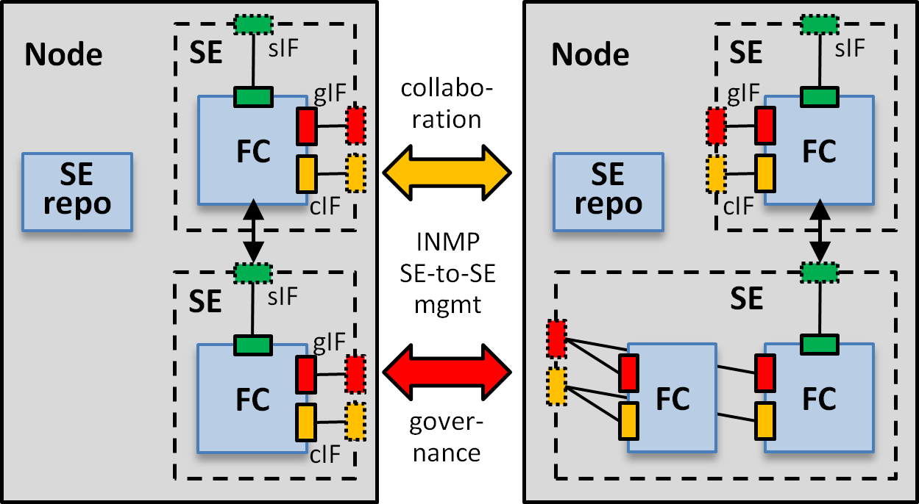

Fig. . Comparing traditional network Management (left) with In-Network Management (right).

The distinction between SEs and FCs is key for the separation between the semantic and implementation level of management processes. On the semantic level, the INM protocol (INMP) mediates all management operations between nodes and works solely on the level of SEs, including, but not limited to, discovery, collaboration, and governance task. The INMP thus does not need to know any implementation-specific details. On the implementation level, functional components implement node architecture-specific management processes or parts thereof. For instance, different operating systems may provide their individual combination and wiring of functional components to build a specific SE. On each node, an INM repository contains a description of the node’s structure in terms of embedded management, which is required to resolve INMP requests to the FCs and their MCs at a node. In Fig. 2, the SE repository is indicated by a dedicated functional component, but it may as well be implemented in a distributed way within the FCs of one or more SEs.
Fig. 1. Comparing traditional network management (left side) with in-network management (right side).
Fig. 2. Main architectural elements of the framework for INM.

Embedding of Management Algorithms
The INM framework [1] defines a systematic approach to the way management functionality (represented by code corresponding to specialized algorithms) is to be implemented in a system. This is in contrast with modern management systems, where we recognized a more ad-hoc approach to implementing FCAPS functionality at different layers in the OSI classification.
We define management functionality as inherent when it is coupled with the network service functionality in an indistinguishable manner. An example of individual management functionality implemented inherently today would be that associated to the automatic configuration, monitoring and failover mechanisms included in the IEEE 802.3ad Link Aggregation standard. In an INM context, such tight integration is likely to result in the existence of a large set of coordinated, collaborating lightweight management functions.
The integrated management functionality is defined as a way of embedding similar to the composition relationship in UML: component-based management functionality is coupled with the network service functionality in a symbiotic relationship. Choosing an integrated degree of embedding allows the developer to pick algorithms from a standard library, extend them to fit particular requirements of the problem, integrate them with the code that provides network services, and then operate the management functionality as one feature of a multi-dimensional management plane.
The separated degree of embedding is matching an aggregation relationship in UML: management functionality is part of the network at large, but the integration with the services is done via weaker bonds. In INM, such approach would determine a powerful management overlay that offers specialized services in a SOA or web services manner.
Finally, the external degree of embedding is characterized by a total decoupling between the management and the network service functionality. This is similar to the majority of the best practices-based implementations in modern telecommunication networks. It was included in the list of definitions in order to complete the design space, but will not be approached in the context of this article.

Selecting the Degree of Embedding
The aim of the INM framework is to enable the same functionality and management mechanisms to be presented in a coherent manner regardless on the degree of embedding. Choosing a particular degree of embedding is viewed as a design choice that could be influenced by a multitude of factors, including reusability, effectiveness, and business-related considerations.
A counter monitoring algorithm, for example, could be implemented as in the following scenarios in order to support a self-managing protocol for data transfers:
a) provide aggregate values to running instances of the same protocol
b) provide aggregate values and enable auditing of the protocol’s activity by entities located higher up in the service organizational hierarchy
In scenario a), an inherent level of embedding would seem a natural choice that would keep functionality and interactions as local as possible. The algorithm itself would be implemented as a management capability. The data exchanges between running instances would be made through the collaboration interface of the FC or SE that contains the full implementation of the protocol. However, since the functionality covered by the monitoring algorithm is only for internal use it would not need to be exposed as a MC over the governance interface of the FC or SE.
In scenario b), the monitoring algorithm would also be implemented as a management capability. However, this capability would need to be exposed over both the collaboration and the governance interfaces of the data transfer FC or SE. The collaboration interface would take care of the internal communications required in order to calculate the aggregates inside the network. The governance interface would handle the requests for reports and deliver the reports to their destination. In terms of degree of embedding, the developer would have a choice between inherent, integrated and separated. Although at this time we have yet to elaborate on the set of guidelines on how to optimally consider a degree of embedding, an integrated approach would probably give the best results in this scenario. This is expected to be more efficient in terms of code reuse compared to the inherent case, and provide additional freedom for customization compared to a separated embedding.

Decentralized Real-time Monitoring
Decentralized real-time monitoring is a key building block for realizing the INM vision. It provides the necessary input to the decision-making process of network management, enabling management systems to perform self-configuration and self-healing tasks.
We are developing a family of decentralized protocols for monitoring network-wide aggregates in real-time. Such aggregates are computed across nodes in a neighborhood, a network domain or the entire network using aggregation functions, such as SUM, AVERAGE and MAX. Example aggregates are the total number of VoIP flows, the maximum link utilization, the histogram of the current load across routers, or the distribution of the router out-degree in a network domain [10].
In traditional network and systems management, monitoring is performed on a per-device basis, whereby a monitoring station periodically polls devices in its domain for the values of local variables, such as devices counters or performance parameters. These variables are then processed on the management station to compute an estimate of an aggregate, which is analyzed and acted upon by other management programs. SNMP is probably the best-known protocol that supports this monitoring paradigm.
As we have argued before, this approach has proved unfit to cope with emerging large-scale, dynamic networks.

In the literature, two approaches are described to compute aggregates in a distributed fashion. The first is based on using a spanning tree, where the aggregate is incrementally computed from the leaves towards the root [4][5]. The result of the computation is available at the root node. More recently, results have been reported on computing aggregates using gossiping protocols [6][7]. In this case, the result of the computation is available on all nodes, and it converges probabilistically to the true value (when the local variables remain constant).
Our family of protocols includes both tree-based and gossip-based protocols. The tree-based approaches make tractable the problem of quantitatively controlling the accuracy objectives, while it remains unknown whether this is feasible for a gossip-based approach. Gossip-based approaches are promising for they do not require maintaining a tree, which can prove costly in dynamic scenarios, like mobile networks.
Next, we present two of our protocols, namely, TG-GAP [2] and A-GAP [3]. Following the discussion in the previous section, the degree of embedding for these protocols is integrated.

TG-GAP: Threshold Detection using Gossiping
Threshold crossing alerts (TCAs) indicate to a management system that a monitored management variable, for instance a MIB object, has crossed a preconﬁgured value—the threshold. Variables that are monitored for TCAs typically contain performance-related data, such as link utilization or packet drop rates. In order to avoid repeated TCAs in case the monitored variable oscillates, a threshold T^{g+} is typically accompanied by a second threshold T^{g-} called the hysteresis threshold, set to a lower value (Fig. 3Fig 3). The hysteresis threshold must be crossed, in order to clear the TCA and allow a new TCA to be triggered when the threshold is crossed again.
Fig. 4. Adaptation time as a function of the incurred overhead for a network of 200 nodes.
Is the figure referenced somewhere? I did not find it ☺
We have explored the use of gossip-type aggregation protocols to distributed detection of threshold crossings of aggregates. Gossip protocols iteratively reﬁne a local estimate of a global aggregate by nearest neighbor interactions. The key idea in our protocols is to let nodes dynamically adjust the protocol rate according to how far their local estimate of the aggregate is from the threshold. We have identiﬁed a family of protocols, organized according to the rate adjustment mechanism, the mechanism for triggering threshold crossing alerts, and whether or not the protocol exploits the symmetry in TCA detection by implementing a hysteresis-like functionality. Key points in the design space have been evaluated, by simulation, for efficiency, quality of detection, scalability, and controllability. The results are promising: when the aggregate is far from the threshold the protocol overhead is negligible (SGM in Fig 3), and when the aggregate is close to the threshold the overhead is comparable with that of the underlying aggregation protocol (NNM in Fig 3). We obtained small detection delays and, for the scenarios considered in this paper, absence of false positives and false negatives. Regarding scalability, at least for the scenarios considered in this paper, we did not observe any significant dependence of detection delay on system size. Finally, as we show in [2] the trade-off between overhead and detection delay is controlled through the protocol configuration.

A-GAP: Controlling Performance Trade-offs
A-GAP is a protocol for continuous monitoring of aggregates, which aims at achieving a given monitoring accuracy with minimal overhead. A-GAP is decentralized and asynchronous. It executes on an overlay that interconnects management processes associated with the devices. On this overlay, the protocol maintains a spanning tree and updates the aggregate through incremental aggregation. Based on a stochastic model, it dynamically configures local filters that control whether an update is sent towards the root of the tree. These filters are the mechanism we use for trading accuracy and overhead.
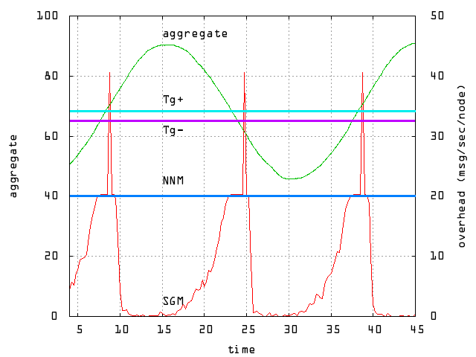
Fig. 3. The protocol overhead over time for the SGM and NNM protocols
Our goal is to understand how to control the performance trade-offs of A-GAP through the aggregation tree topology. Specifically, we want to understand the trade-off between management overhead and adaptation time to changes in the networking conditions. Figure 4 shows simulation results for a network of 200 nodes. Every point in the figure corresponds to a different aggregation tree topology. As can be seen, the adaptation time decreases monotonically, as the overhead increases. For smaller overheads, the adaptation time decreases faster than for larger overheads. Consequently, the adaptation time can be reduced by allowing a larger overhead. For example, compared to an overhead of 18,3 updates/sec, allowing an overhead of 20,5 updates/sec reduces the adaptation time by 55%. An overhead of 29,1 updates/sec reduces the adaptation time by 97%.

Event Handling
Distribution of events is an important functionality in INM and it has a higher number of applications than in traditional approaches. In fact, events are applied not only in fault management for the delivery of events, but they enable two other important mechanisms for distributed management: (i) the paradigm of management by exception and (ii) activation of local management functions.
The challenge in INM is to realize event distribution through a P2P mechanism, where no initial configuration is required. In other words, INM nodes should activate their event distribution function with no a priori configuration and guarantee timeliness. This is quite different from traditional solutions for at least two aspects: firstly, a high degree of distribution is envisaged and the sinks of events cannot be known a priori; secondly, each node should find the best entity to handle an event and eventually adapt previous choices to meet certain timeliness requirements. An analysis of technical issues, their trade-offs and simulation results will help us to isolate the relevant metrics.
On the basis of existing techniques for fault and performance management, like those reported in [8][9], we identified four roles for our distribution mechanism, which are presented hereafter and depicted in Fig 5. Since, different techniques for event correlation exist, the handlers role represents general network functions, that can be instantiated with any specific engine or user interface. They are used, instead, as architectural elements to support a complete distributed mechanism.

Fig. . Event handling framework.
Based on this architecture, we performed different scenario simulations to evaluate two key metrics: completion time and traffic consumption. We performed the evaluation considering two different mechanisms to deliver events across the distributed handlers in the network: sequential, where the handlers are invoked on a hop-by-hop basis, and parallel, where the invocation occurs in a parallel basis. In addition, we considered two scenarios: in the first one (called “homogenous”) all the handlers have the same capability of producing a successful analysis, while in the second the handlers closer to the event generator have less probability of success. The numerical results are presented in Table I and show that the non homogeneous scenario (columns on the right side) presents worse results, with very long completion times and high traffic generated. This is due to the fact that the closest handlers are with high probability unable to handle events with success, and the events have to be forwarded to the further handlers, with a consequent worsening of the performances. Nevertheless if we compare the case of sequential and the parallel 2, we can see that worsening does not happen in equal manner: the former increases of 3.75 times, while the latter increase of 5.87 times. The result appear at first unexpected, because a parallel distribution would always fill the topology in less steps. In reality, this increase is caused by those occurrences when an event could not be handled by any nodes in the network.
Fig. 5. Event handling framework.
TABLE I
Completion time and traffic results of simulations with 1000 events generated and computational capability of 10 event
 | Homogeneous scenario |  | Non homogeneous scen.
mode | completion time (avg), ms | traffic (avg), # messages | completion time (avg), ms | traffic (avg), # messages
sequential | 111.1 | 1.9 | 417.3 | 3.4
parallel 2 | 37.3 | 6.0 | 218.9 | 10.3
parallel 3 | 28.9 | 11.1 | 173.7 | 18.0
parallel 4 | 29.7 | 14.3 | 171.8 | 21.8
parallel 5 | 31.4 | 16.3 | 161.9 | 25.2
parallel 6 | 29.1 | 17.9 | 159.0 | 26.0

Additionally, the results show that a preliminary partitioning of the handlers is required to reduce the completion time with the parallel mechanism. This case occurs with more frequency in the non homogenous scenario and therefore the worsening of the performances is higher than in the sequential mode.
TABLE I
Completion time and traffic results of simulations with 1000 events generated and computational capability of 10 event
 | Homogeneous scenario |  | Non homogeneous scen.
mode | completion time (avg), ms | traffic (avg), # messages | completion time (avg), ms | traffic (avg), # messages
sequential | 111.1 | 1.9 | 417.3 | 3.4
parallel 2 | 37.3 | 6.0 | 218.9 | 10.3
parallel 3 | 28.9 | 11.1 | 173.7 | 18.0
parallel 4 | 29.7 | 14.3 | 171.8 | 21.8
parallel 5 | 31.4 | 16.3 | 161.9 | 25.2
parallel 6 | 29.1 | 17.9 | 159.0 | 26.0

Conclusion
INM is a new management paradigm for the future Internet aimed at overcoming the limitations of traditional management approaches in order to cope with large-scale dynamic networks. Its key idea is that management stations outside the network delegate management tasks to a self-organizing management plane that is embedded within the communication network.
In this paper, we have shown how decentralized management algorithms can be enabled and supported by a framework for INM. We have presented algorithms for real-time monitoring and event handling, two key management functions in the context of INM. We have shown the benefits of these decentralized algorithms in comparison to traditional approaches of network management.
We are currently investigating how a complete management control cycle is to be implemented within a self-organizing management plane in the context of embedded management process lifecycles. Besides the presented algorithms, we are investigating algorithms for other management functions, including distributed anomaly detection, self-healing and situation awareness.
Acknowledgment
This work has been part of 4WARD, a 7th Framework ISP project funded by the EC. We would like to thank our colleagues in the 4WARD project for fruitful discussions.

References
- D. Dudkowski et al., “Architectural Principles and Elements of In-Network Management”, accepted for the Mini-Conference at the 11th IFIP/IEEE International Symposium on Integrated Network Management (IM 2009), New York, USA, June 2009.
- F. Wuhib, et al., "Gossiping for Threshold Detection", accepted for the 11th IFIP/IEEE International Symposium on Integrated Network Management (IM 2009), New York, USA, June 2009.
- A. Gonzalez Prieto and R. Stadler "Controlling Performance Trade-offs in Adaptive Network Monitoring", accepted for the 11th IFIP/IEEE International Symposium on Integrated Network Management (IM 2009), New York, USA, June 2009.
- S. R. Madden et al., “TAG: a tiny aggregation service for ad-hoc sensor networks”, 5th Symposium on Operating Systems Design and Implementation, Boston, USA, December 2002.
- M. A. Sharaf et al., “Balancing energy efficiency and quality of aggregate data in sensor networks”, ACM International Journal on Very Large Data Bases, 13(4), December 2004.
- M. Jelasity et al., “Gossip-based aggregation in large dynamic networks,” ACM Transactions on Computer Systems, 23(3), Aug. 2005.
- D. Kempe et al.“Gossip-Based Computation of Aggregate Information,” 44th Annual IEEE Symposium on Foundation of Computer Science (FOCS 2003), Cambridge, USA, October 2003.
- J.P. Martin-Flatin et al., "Event Correlation in Integrated Management: Lessons Learned and Outlook”, Journal of Network and Systems Management, Vol. 17, No. 4, pp. 481-502, December 2007.
- M. Leitner,et al., ”Fault Management based on peer-to-peer paradigms; A case study report from the CELTIC project Madeira”, 10th IFIP/IEEE International Symposium on Integrated Network Management (IM 2007), Munich, Germany, May 2007.
- R. Roth et al., “Definition of scenarios and use cases”, the FP7 4WARD Project deliverable, available at: http://www.4ward-project.eu/index.php?s=file_download&id=6

 

