Going 4WARD
Newsletter

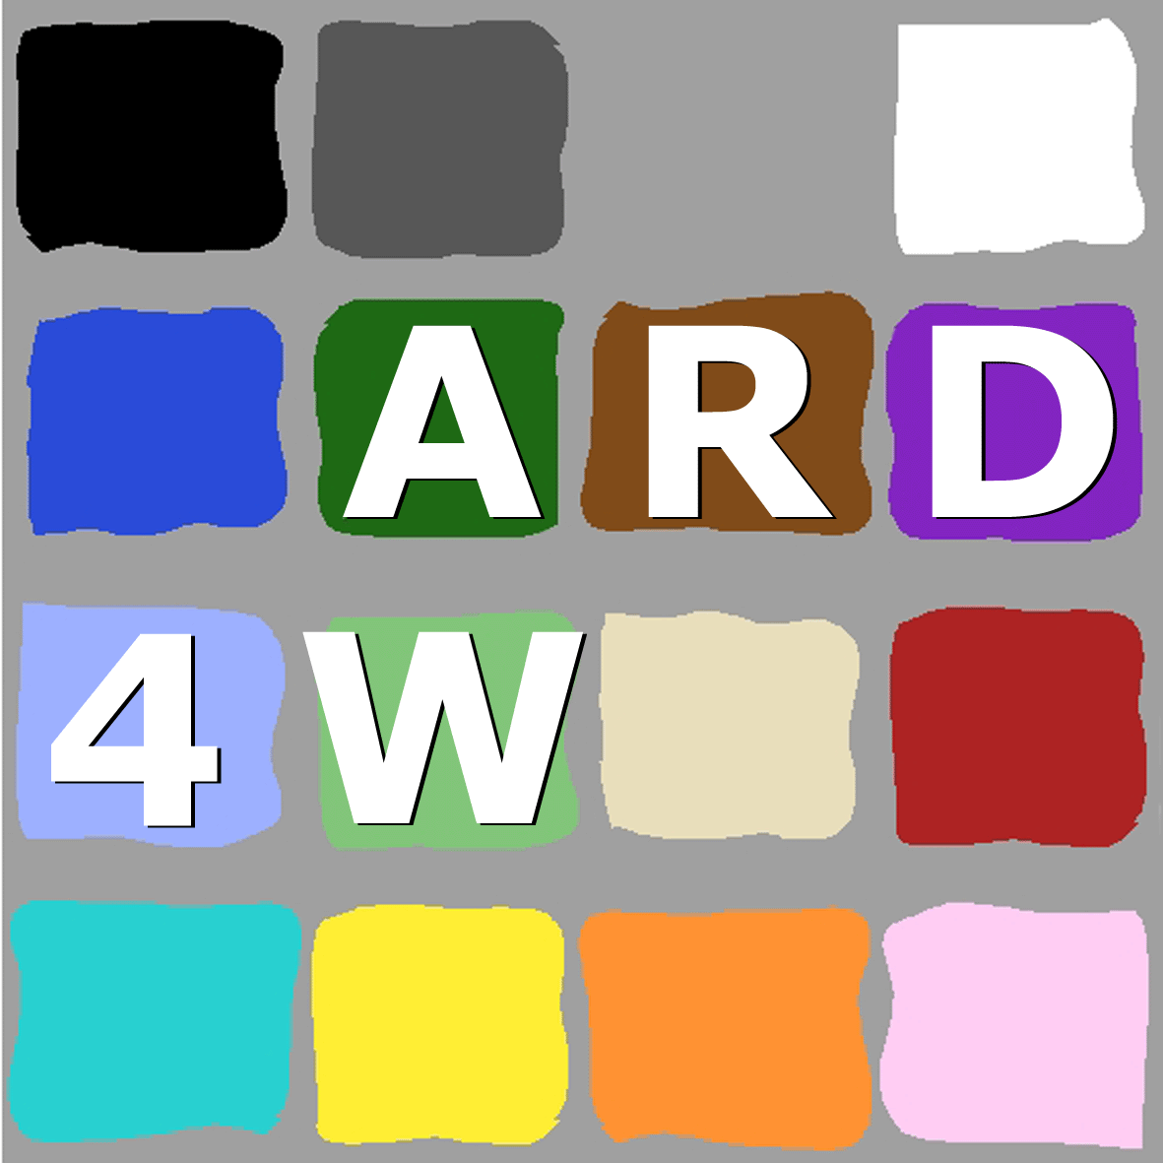 | 4WARD  Architecture and Design for the Future Internet
Issue No. 3  Mar. 2009 | Editors: Luis M. Correia and Lars Lundgren

Inside this Issue
1. Editorial
2. On the Spotlight: Focus on WP6
3. Inside 4WARD: News from WPs and
Themes
4. Looking Outside: Views on 4WARD
5. What’s Next: Incoming Events

1. Editorial
In the first year of work, 4WARD has produced a number of deliverables on business perspectives, requirements, architecture framework, network virtualisation and management, generic paths, and networking of information. In this newsletter, we focus on the networking of information, showing how we better can support access and dissemination of information in comparison to traditional ways.
The 4th general meeting was held in Lisbon, where the direction of the future work for all WPs was set. At the plenary, John Day, the author of Patterns in Network Architecture: A Return to Fundamentals gave a talk questioning the current communications paradigms also serving as an inspiration for future research.
After having been in a bit of independent research mode in the different WPs, we are now embarking on an integration phase with a number of joint tasks. Further to that, we will continue with our special task force on Architecture in order to ensure a systems approach to the work in 4WARD.
We have been active in supporting the Future Internet Assembly by organising breakout sessions on Management and Service Aware Networking Architecture for the Madrid event and other sessions. There has also been a submission of a paper for the Prague meeting.
Henrik Abramowicz
2. On the Spotlight:
Focus on WP6
In WP6 - Networking of Information, we are exploring the design space and evaluating the feasibility of an information-centric approach to networking. In the information-centric paradigm, which we call NetInf, the content, or information objects, are first-class network citizens, independent from the devices they are stored on. We believe that this approach can better meet the needs for the information distribution applications that are dominating the usage of current networks, provide better service in face of connectivity disruptions and protection against malicious and unwanted traffic.
In contrast, current networks are based on a device-centric paradigm, which focuses on the interconnection of devices, such as computers, mobile devices, servers and routers. Here, the information objects themselves are lacking identity independently of the devices they are stored on. The dominating method of transferring information using an end-to-end TCP connection makes the information more or less anonymous to the devices it passes through, making it hard to create efficient distribution schemes using caching to avoid redundant transfers.
During the first year, an information model has been developed. It distinguishes between information object (IO), capturing the semantics of an object, and bit-level object (BO), which is a particular sequence of bits independent of any semantics. The BO is what is delivered from the transport network to the application/user, with or without involvement of NetInf. To retrieve an object using NetInf, it takes an identifier of an IO or a set of attributes that is mapped to matching IOs as input. The NetInf name resolution process will result in identification of an appropriate BO, which is then requested from the underlying transport network. The concept of information object is general enough to handle real-world objects as well as services.
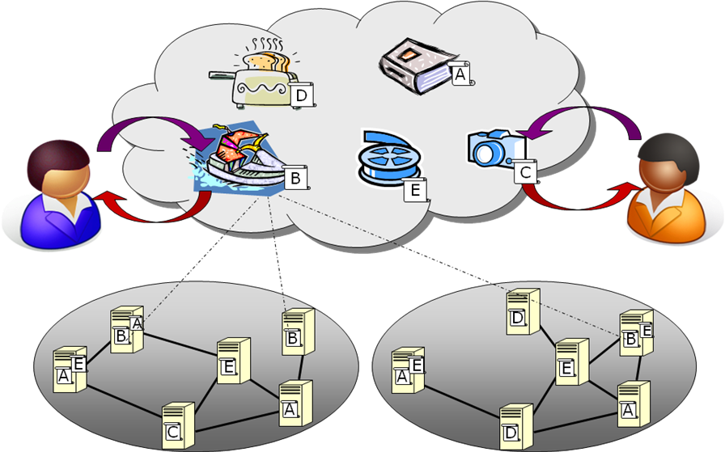
A global NetInf system will need to handle a very large number of objects. Today’s networks deal with a limited number of nodes in the network, compared to all the information objects stored in them. Google reported in Summer 2008 that they hit the milestone of 10¹² unique URLs on the web. As we anticipate a continued vast increase in both network nodes and information objects, including both real world objects and services, designing scalable name resolution and routing for NetInf is a major challenge. To address this challenge, we have investigated two different approaches: one is the Multiple DHTs Architecture (MDHT), which is a DHT-based hierarchical approach to the design an integrated name resolution and routing system; another is the Late Locator Construction (LLC) architecture, in which the locator of an object is constructed at the time of session initiation in order to take fresh topology information into account. This makes it possible to use NetInf also in highly dynamic networking environment with both moving nodes and networks. Initial assessments of the two approaches have been made through evaluations and simulations.

3. Inside 4WARD:
News from WPs and Themes
WP1
Business Innovation, Regulation & Dissemination
The main focuses during the last months were the completion of its first public Deliverable, D1.1 - First Project-wide Assessment on Non-technical Drivers, and the use-cases work.
Regarding D1.1, it was issues in Jan. 2009, and outlines and assesses non-technical drivers from the areas of Usage and Services, Socio-Economics, and Policy, Governance and Regulation in the context of Future Internet technical innovations. A large number of potential issues have been identified that can influence 4WARD’s technical developments and the Future Internet (FI) as a whole. The selection of the most important issues paved the way for the definition of major non-technical requirements, which have been condensed in several guidelines for the technical WPs.
Two business use-cases have already been partially developed: one focusing on new business fields and value chains arising from virtualisation techniques on the networking layer, and the other focussing on new ways of information delivery. Further work to finalise these use-cases is still needed, e.g., with the inclusion of Policy, Governance and Regulation issues. Further use-cases will also be developed with emphasis on Future Internet applications, as a means of showing how the 4WARD results will allow the development and implementation of new innovative ideas.
WP2
New Architecture Principles and Concepts
WP2 has delivered D2.2 - Draft Architecture Framework. This framework has resulted after the convergence of the top-down and bottom-up approaches, which were aimed at providing both macroscopic and microscopic views of the Network Architecture, respectively. Moreover, WP2 has progressed on a new approach towards an innovative design process for the networks of the future, applying "best practices" as well as methodologies of software engineering and of network architecture design. A model-driven process has been defined, which allows the workflow ranging from a business idea (high level requirements) as a starting point through various levels of models (e.g., meta-models) to the design of network and software architecture.
Work on the interoperability issue has recently intensified. Up to now, it mainly concentrated on aspects related to the interoperation across network domains in order to preserve the application characteristics. In particular, WP2 has focused on the identification of key aspects with respect to the interoperability of different domains. They comprise the negotiation of the business level agreements between different providers in order to provision the framework (at the different levels) to preserve the end-to-end application characteristics. Different types of agreements have been studied and have demonstrated the flexibility of the defined Architecture Framework.
WP3
Network Virtualisation
While full experimental evaluation of results will mostly take place in the second year, the WP has already engaged in a number of small-scale prototyping activities to support conceptual development and early validation. Several project partners are cooperating on such "bottom-up" activities using prototyping.
In order to enable remote control and management of virtualised resources, basic functions and primitives of a Virtualisation Management Interface (VMI) have been implemented. The primitives include the creation and destruction of virtual resources within a physical resource, the connection of nodes and links to interfaces, and functions for its configuration. In another testbed, the basic functions of the infrastructure and the VNet provider were implemented.
Furthermore, the prototype offers on-demand operational and management capabilities, which are typically performed by the VNet operator. In line with some scenarios of the VNet architecture, the combined tasks of VNet provisioning and management are assigned to a single entity. The prototype mainly provides a topology of virtual nodes based on specific requests of the VNet provider, followed by the instantiation (and optionally the on-demand management) of this network.
A further prototyping activity is focussing on software-based virtual routers. Virtualised forwarding planes were evaluated in terms of performance, isolation, and fairness. The experiments were conducted on an SMP multi-core platform running Xen and Click Modular Router for forwarding. It was shown that a virtual router platform based on commodity hardware can forward packets at very respectable rates. The tests demonstrated that it is possible to implement virtual routers that support high packet forwarding rates combined with the flexibility and programmability afforded by general-purpose processors.
As a preparation for integrated tests, the testbeds of several project partners have been interconnected. The WP is implementing a framework to allow sharing of resources for experiments across partner sites.
WP4
In Network Management
WP4 has completed its first design document, D4.2 - In-Network Management Concept, which proposes a synthesis of the main concepts discussed in the first year. Self-management is supported through the aggregation of management capabilities into Self-Managing Entities (SEs), which are responsible for aggregating distributed functions and guaranteeing the satisfaction of specific objectives (e.g., SLAs). An SE is composed of a set of Functional Components (FCs), which can be mapped onto modular blocks of network functions, such as modules of a Generic Path or of the VNet framework.
Additionally, the design document contains a first study on business values of In-Network Management (INM). It proposes an analysis of the potential impact of self-x features of INM on the reduction of OPEX and CAPEX for network operators. Since INM is proposing a new approach to manage large-scale networks, this study will be the basis for a more detailed evaluation on practical implications of self-management techniques.
WP5
Forwarding and Multiplexing for Generic Paths
In the last few months, WP5 has concentrated on the completion of D5.2.0 - Description of Generic Path Mechanism, issued in Jan. 2009, compiling the most recent advances accomplished on network coding and routing. This document presents the generic framework for cooperation and coding in a real network, and highlights the gain that can be obtained by using various types of network and source coding. In parallel, some significant progress has been made with respect to routing. In particular, D5.2.0 identifies some crucial issues related to multi-path routing and multi-technology routing, taking cross-layer information into account. Special attention has been paid to the integration of the various concepts into the general architecture based on generic paths. In turn, this effort has allowed the identification of some shortcomings of the current architecture. Hence, the architecture should be enriched to integrate the new concepts that have appeared essential in the preparation of D5.2.1. A first simulation of the architecture is under development using OMNET++.
D5.2.1 will be drafted by Apr. 2009, with inputs from the tasks dealing with resource and mobility management, which have explored various new topics. Concerning the former, some new ideas were presented at the Bilbao meeting on resource control in optical networks (virtual optical bus, performance of optical switching, etc.) and on the stability of a network when load balancing is performed. Regarding the latter, several mobility schemes are under study and should soon be evaluated via simulation.
A recurrent task, the architecture, as described in D5.1 – Architecture of a Generic Path, is continually discussed and revisited in order to take account of the most recent developments made in other tasks.
WP6
Network of Information
On the Spotlight in this issue.
Service and Usage Theme
The Services and Usage (S&U) theme links the technology with the customer and his needs and requirements, targeting to analyse the benefit of the different technology innovations to users.
The first results include the definition of a S&U framework, the identification of potential S&U issues, and the analysis of technical innovations in order to identify the impact on S&U.
Some relevant guidelines for the technical work have been formulated. FI technologies need to flexibly adapt on service requirements and they shall support:
- A broad range of innovative services, delivered to human customers as well as machines or virtual objects.
- Existing as well as emerging business models, which enable new players to enter commercial and non-commercial services, without disrupting existing services and without jeopardising their evolution.
- Service provider requirements for managing their operations, including information about users and usage patterns, in compliance with legal rules respecting privacy and competition.
- Mass market customer requirements, which implies to provide a satisfactory quality of experience for the average customer and high quality of experience on demand.
Two S&U scenarios have been developed, related to virtual networks and new ways of information delivery. For each business role/user a qualitative value proposition shows many impacts and potential benefits. In addition it can be concluded that there is a huge impact on the current application environment with new network functions that can be integrated and used.
Furthermore, service enablers like virtualised resources or the generic path concept, could support emerging applications in a way that they will decrease complexity and time-to-market without needing knowledge of the applications details. Consequently, the migration of some service aspects could be done more easily with generic service enablers in the platforms.
Socio-economic Theme
In the first year, the Socio-Economic theme work has been developed along the paths of Scenarios, Guidelines, and Business Use Cases.
A great deal of socio-economic items is influencing today’s use of Web 1.0 and 2.0 and people’s way of living. The FI will play a dominant role in the society, as new and far closer relationships are expected to be settled among businesses, the public sector, the citizens, and the consumers on the base of reliable communication networks and services. The key factors in the Socio-Economic area likely to affect the development of the FI include: the ‘degree of mobility’ in the lifestyle, the ‘balance of privacy vs. sharing’, the need for security, the importance ascribed to, e.g., health or the distribution of wealth.
Internet-based services will become ubiquitous and will be underlying to all social and economic infrastructures, changing the society and the economic trends. The Guidelines for the FI are:
- New technologies must support applications with a satisfactory performance under all circumstances for lifeline services, and allow use for the other applications also in critical processes of daily life.
- New services shall address the needs of ageing societies.
- It will be a ‘Green Technology’ and will help saving the environment.
- It will allow communication among persons, between persons and things, and among things.
From the project wide scenario work, several use cases have been defined. Two of them have been analysed in a first round, to highlight the new business areas created by the concepts developed within 4WARD and the impact of technologies on business and consumers.
Policy, Governance and Regulation Theme
Today, the Internet is a critical infrastructure, and more so in the future. It is clear that it will become so important that the governments want to know how it will be being run. The rules, policies and laws become important, and interaction is needed between different communities to make these rules reasonable. The objectives of PG&R (Policy, Governance and Regulation) are to investigate its implications on networking technologies, and vice versa.
The first results outlined the driving forces on all non-technical themes, and defined a frame for the work with a huge number of potential issues that can influence 4WARD project and the FI as a whole. The 2nd step identified the dependencies between PG&R and technical themes, and identified its requirements for the FI.
In the 1st half of 2009, the PG&R work will concentrate on the elaboration of the Research Questions. The focus areas will be:
- Identification of the elements/drivers of the economic efficiency in the FI and how they contribute to consumer’s welfare. The reason for this task is that increasing consumer welfare is the main objective of the regulation.
- Identification of the areas where new investments are needed in the FI. The argument for this task is that the regulation has to create a fair and predictable investment environment to boost competition, and competition increases consumer’s welfare.
- Interconnectivity, access, and aspects of net neutrality, which are currently, and probably also in the future, key issues in regulation.
Quality of Service Theme
Whatever the Internet turns out to be in the future, one thing is certain – it will be expected to support a myriad of application and services, with a very wide range of characteristics and needs. For different reasons, predictability of performance and QoS (Quality of Service) will represent a crucial requirement in many application scenarios, e.g., voice, TV, video-on-demand, online gaming, telemedicine, e-finance, and emergency. It’s clear that the traditional simplistic “over provisioned best effort” approach will not provide a universal solution. Therefore, the capability to control QoS in a flexible and efficient manner will surely constitute an essential requirement in the FI.
On the other hand, FI demands a fresh technical approach to the QoS problem. The traditional QoS building blocks and techniques must be reassessed in the light of new networking concepts. Several problems should be reevaluated, taking into account new proposals for the FI: how to guarantee scalability; how to control network resources dynamically; how to achieve end-to-end QoS over heterogeneous networks or across different administrative domains; how to handle coexistence of QoS with other features, e.g., mobility, security, multicast. New networking ideas and concepts will certainly bring new ways of dealing with these problems.
Novel technologies and architectural concepts, such as generic path, network virtualisation and in-network management, will potentially have an impact in the way QoS can be provisioned, controlled and monitored in future networks. The primary goal of QoS activity is to perform an overall evaluation of the 4WARD architecture from a QoS perspective and how it could lead to create better, simpler or more efficient QoS techniques in a FI environment. Naturally, aspects such as business models and regulation environment are not to be forgotten. The QoS group is halfway through achieving these goals. A set of requirements was defined in the initial months of the project, and the work to achieve a global cross-WP view on the theme is currently in progress, with the contribution from all WPs.
Mobility Theme
4WARD recognises that, in the future, wireless network access will dominate, for personal communication whether at home, on the move, or in business. Moreover, communication will have to cover new technology and application areas where the number of connected devices will exceed current numbers by an order of magnitude or more: the “Internet of Things“ will connect machines to machines, as well as all kinds of sensor devices, typically wirelessly, and often mobile.
During the first year, the Mobility theme has focused on studying the relationships of the 4WARD research areas, as represented by the six WPs, with respect to new and innovative mobility approaches and use-case scenarios.
Special consideration has been given to the mobility theme throughout the architecture. “Generic Path” allows a variety of innovative mobility solutions that will be further investigated in the second project year. By the “Network of information”, it is possible to manage more abstract mobile objects including the coherent management of different devices, applications and contents assigned to a certain user or owner. “Virtual network operators” will share physical networks, in particular wireless access networks, and therefore need a consistent mobility architecture to provide a seamless access to the heterogeneous technologies. “In-Network Management” will provide generic functions to manage the mobility-related resources for virtualised networks, and provide new functionalities, e.g., to monitor and collect dedicated mobility-related knowledge, like topology discovery or context awareness.
Security Theme
Security issues are cross-WP in nature. How user privacy is balanced against the business interests of different parties involved is ultimately a PG&R decision crossing legal boundaries. Sharing of technical information about network resources and real-time dynamic state will be an inherent feature of future networks. Large scale state aggregation potentially involves network devices sharing state information across provider boundaries. Can this be done without jeopardising the privacy of configuration policies and performance statistics that are internal to each collaborating network provider? And, is it possible to secure the aggregation process such that it is guaranteed to provide (probabilistically) correct results, even in the presence of non-cooperating or malicious entities?
Virtual Network Operators serving customers through virtual networks built over shared physical infrastructure opens a range of trust related questions addressed in 4WARD both as management and as architectural interoperation functionality. While specifying what kind of certificates or SLAs are needed is premature, the work done has identified a range of interfaces and interaction points (folding points and mediation points) for which the security management becomes a central issue both in setting up the network components and in handling traffic and paths. The end user security is tied to access network credentials, while the core network interaction is protected by active monitoring of traffic against agreements in place.
Since the information-centric paradigm detaches information from the originating host, the distinction between routing and caching becomes blurred. Instead, the integrity, timeliness, and name resolution of information becomes central - the scalability properties will determine the balance between global structures and locally resolved properties, such as addresses. Innovative component approaches, such as the publish-subscribe paradigm and Distributed Hash Tables for flat name space resolution are investigated as potential pieces of future networks. New naming and name resolution structurally addresses problems coming from excessive control currently residing at the weakly identifiable sender, such as denial of service and unwanted traffic.
Physical Layer Awareness Theme
One of the main motivation of the Physical Layer Awareness (PLA) Theme is to provide inputs for deriving Physical Layer related requirements, at different levels, while aiming at clearly identifying the dependency among channel impairments and network parameters/ characteristics, therefore, providing the basis for the Physical Layer virtualisation process.
An updated version of the internal PLA main document was delivered in Jan. 2009, which includes a new chapter on Optical Channel awareness and new contents on the evaluation of how network parameters/characteristics are affected by channel impairments.
Future work includes going through the deliverables that have already been submitted in order to identify possible aspects where Physical Layer impairments are not being (or not properly) taken into account. The main objective is to check the Physical Layer Awareness within 4WARD as a whole, given the current project development stage.
Interprovider Theme
When designing the foundations for a FI, 4WARD has learnt from the past. One of the shortcomings of the current Internet is the lack of clear models and incentives for Providers. In our work, we have approach this problem and that of the relations between providers in a holistic approach across all WPs.
In the first year, the Interprovider Theme has provided a common view of the point of interconnection between providers (i.e., demarcation point). It is present in the Architecture Blueprints of WP2, in WP3's Folding Points, and in the Mediation Points of WP5.
This close collaboration will continue, in order to assure a coherent definition of the business interfaces between providers in the Architectural Blueprints. Some preparation has already been carried out in WP1, which has studied them in different use cases.

4. Looking Outside:
Views on 4WARD
4WARD has participated in several conferences, for example ReArch 2008, WTC at Globecom 2008 and ACM CoNEXT 2008.
4WARD’s end-of-year deliverables have been issued, and all public deliverables for 2008 are now available at web site: http://www.4ward-project.eu/index.php?s=publications.
The 4th General Meeting has been held successfully. It was well attended by partners, taking place in Lisbon during the last week of Jan. 2009 at IST-TUL. John Day (author of the book “Patterns in Network Architecture: A Return to Fundamentals”) held the key-note speech and a workshop, courtesy of TSSG. The 5th General Meeting will be held in Sep. 2009.

5. What’s Next:
Incoming Events
The preliminary program for the Future Internet Summer School 2009 (FISS’09) is now available at https://www.comnets.uni-bremen.de/typo3site/index.php?id=101 and http://www.4ward-project.eu/index.php?s=news. For more information and further announcements please contact: fiss@comnets.uni-bremen.de

4WARD will be participating in conferences and workshops in 2009:
- ICN, Cancun, MX, Mar. 01-06
- Workshop on Overlay and Network Virtualisation, Kassel, DE, Mar. 06
- IEEE Infocom, Rio de Janeiro, BR, Apr. 19-25
- IEEE VTC, Barcelona, Spain, Apr. 26-29
- IFIP/TC6 Networking, Aachen, DE, May 11-15
- FIA Conference, Prague, CZ, May 11-13
- GameNets, Istanbul, TR, May 13-15
- IM, Long Island, NY, USA, June 1-5
- IEEE ICC, Dresden, DE, June 14-18

Final Notice
For more information, go to the project website (http://www.4ward-project.eu), or contact via email at 4ward-contact@verkstad.net.

http://googleblog.blogspot.com/2008/07/we-knew-web-was-big.html

